CAP Check-In with
Barcode Scanner

Install
Unzip and copy the CAPCheckIn.exe to a dedicated folder. Do not include the version number in the folder name. Future versions will be copied into the same folder and will not lose any data. It will create a few folders and files so it is best to be in a folder dedicated to this application. Create a shortcut on the desktop. For more information, see the read me found in the application.

Barcode Scanning
Log into the computer
Double Click in the CAPCheckIn
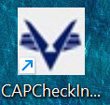
The program defaults to a file dated today. You can change to a previous file by using the “Browse & Open Scan File” button.
Have cadets and senior members scan cards. The file is saved after each scan.
At the end of the day, click the “Copy Scans to Clipboard” and proceed to importing into eServices.

Import into eServices
NOTE: Open a GUEST profile so your password for eServices is not saved.
Sign in with your CAP ID and password
Click on Menu – Personnel – Attendance Log
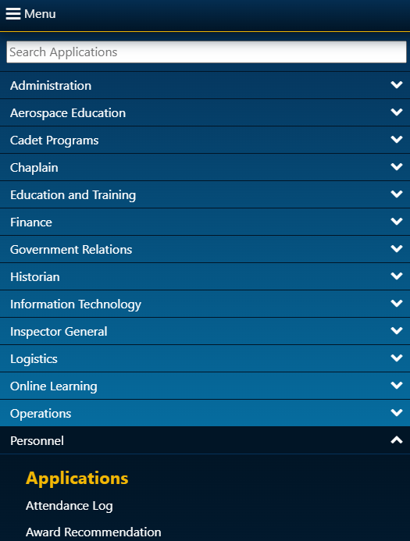
Click “New Meeting”
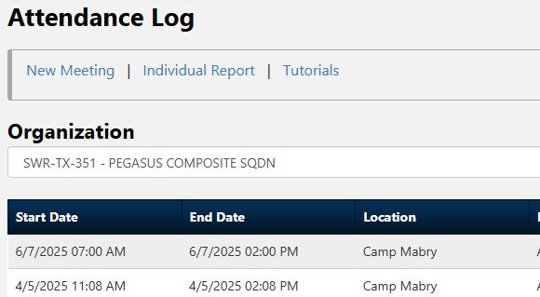
Pick Organization

Pick Meeting start and stop time
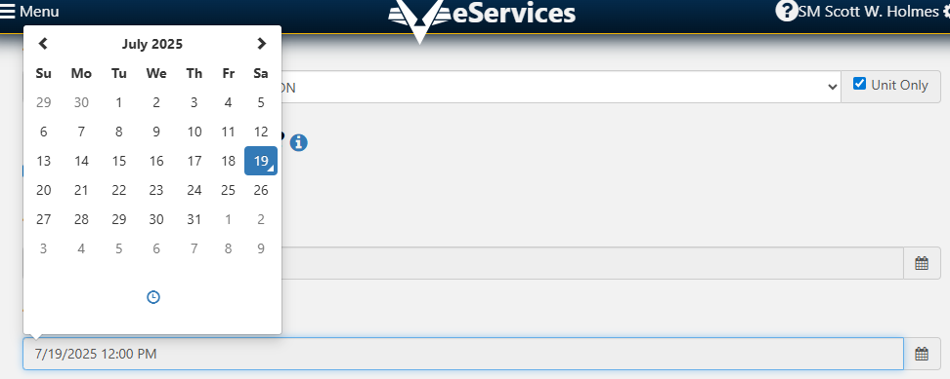
Select Member Type (normally All Members)
Location – You know where you are
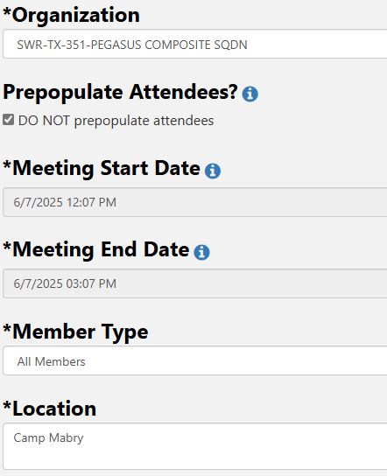
Select Topics for that meeting
Click Create
Paste all the CAP IDs into the Bulk Entry field of the meeting you created
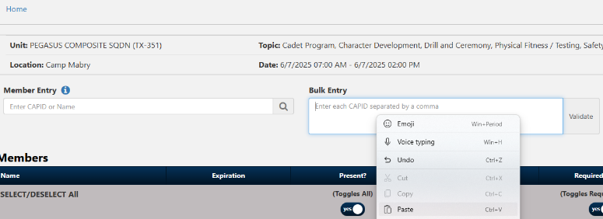
Click Validate
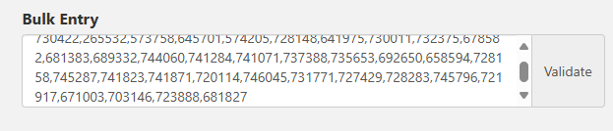
You should see people being checked in.
Click “Save Attendance” at the bottom
